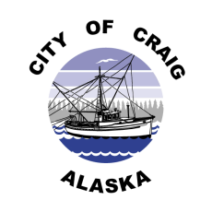

**Job Opening**

**Job Title:** **City Administrator**

**Pay Rate:** **Based on employment contract**

**Department:** Administration, City of Craig

**Date Posted:** September 17, 2021

**Position Summary**

The city administrator shall, under the direction of the mayor, perform and supervise work of city staff, including fiscal, personnel, supply, training, public information and planning services.

**Qualifications**

* At least three year’s work experience as city administrator, or relevant municipal experience in another supervisory position, preferably in Alaska.
* Bachelor’s or master’s degree in public administration, rural development, or related field.
* Demonstrated knowledge of Title 29 of Alaska Statutes.
* Demonstrated knowledge of strong mayor form of local government.
* Any combination of education of a bachelor’s degree and work experience that provides the applicant with the skills, knowledge, and ability required to perform the duties of the position.
* Must be bondable.
* Must embrace and support the City of Craig mission and its implied values and behaviors.

**Hours of Work**

Nominal work hours are 8:00 a.m. to 5:00 p.m. Monday through Friday. Applicants are advised that the City Administrator must devote time outside the normal working hours to the business of the city.

**Applications**

Complete job description and application are available at City Hall, 500 Third Street, or online at [www.craigak.com](http://www.craigak.com). Please submit completed applications to [hr@craigak.com](mailto:hr@craigak.com),or drop off at City Hall. ***Position open until filled.***

***The City of Craig is an Equal Opportunity Employer***