Date Posted: May 2, 2018
Open Recruitment Until Position Filled

The Craig Police Department is currently accepting applications for the position of Dispatcher. This is a Full Time position, City Benefits, Medical & Retirement.

QUALIFICATIONS:
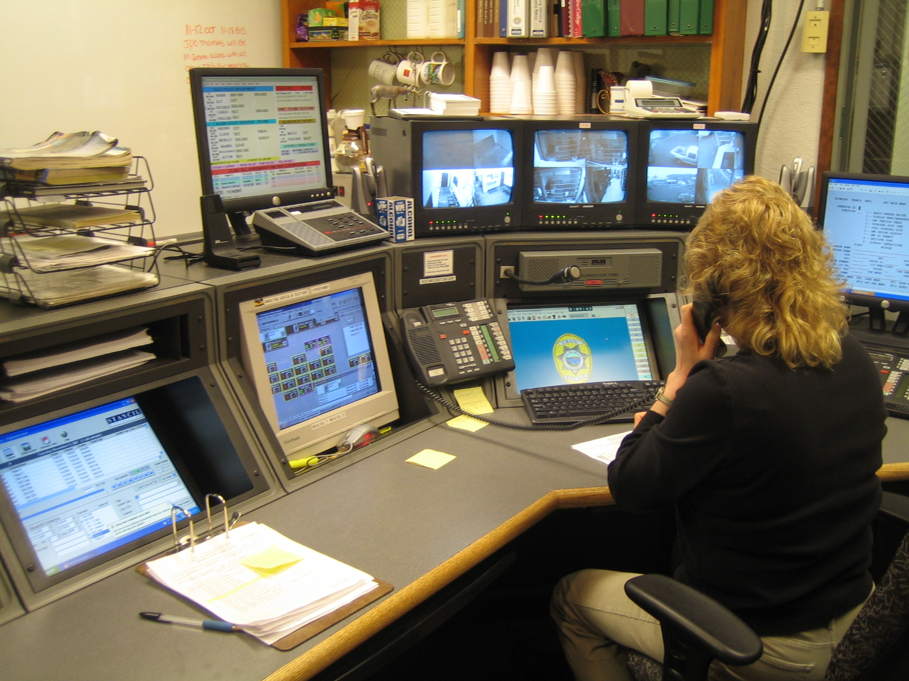

Must be 21 years of age
Must be a high school graduate or equivalent
Must possess very good oral and written communication skills
Must have good knowledge of standard office equipment
Must possess basic computer skills
Must be able to work well with the public
Must not have any prior Felony Convictions

DUTIES INCLUDE BUT ARE NOT LIMITED TO:

Monitor and operate emergency communication and computer equipment such as radio, telephone (911), local alarm systems and paging systems. Maintain exact times and information on Radio/Shift Log. Obtain incoming information and dispatch Police Officers, Emergency Medical and Fire personnel. This position includes some administrative duties such as typing and filing, data entry, administrative distribution, typing letters, booking and monitoring prisoners with the use of a video monitoring system. Other administrative duties as assigned. Shifts consist of nights / weekends and varies from month to month. Training is given at Craig Police Department.

HOURS OF WORK: 40 Hours Per Week

PAY RANGE: Starting Pay $16.00 to $17.99 an Hour / DOE

BENEFITS: Premera Health Insurance for employee and family members. State PERS Retirement System. Overtime pay. After successful completion of probation eligible for paid vacation, paid sick leave and holiday pay (10 holidays per year).

Any offer is contingent upon successful substance screening and Craig Police Department is an Equal Opportunity Employer.

Applications are available at the Craig Police Department or at www.craigpd.com
For more information contact Chief RJ Ely at the Craig Police Department
(907) 826-3330.

