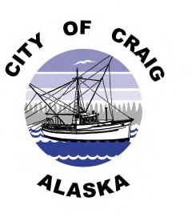

CITY OF CRAIG PUBLIC NOTICE

***Over The Counter Sale***

City of Craig, Craig Police Department is conducting an over the counter sale of the following vehicles, for listed prices:

2005 Chevy AVO 4Door, Black

1991 Ford PK, Red

1994 Toyota PK, Red

2000 Honda REC 4Door, Black

2000 Chevy PK, Blue

1997 Nissan MAX 4Door, Black

2003 Ford WIN VP, Gold

1989 Chevy PK, Tan

1990 Chevy PK, Tan with camper shell

Above listed vehicles, no key’s available, unknown if they run and are sold “as is” for $25.00 dollars per vehicle

1984 Ford F150, Blue (have keys & runs)

1993 Dodge PK, Black (run’s, no key)

1997 Ford XPL LL, Gray (run’s, have keys

Above listed vehicles, ran at one point, have key or way of starting and are sold “as is” for $50.00 dollars

Starting Thursday, August 10, 2023 at 8:00 AM you can come to the Craig Police Department, 506 2nd Street, Craig, AK 99921 and purchase any of the above listed vehicles. Sale ends Friday, August 11, 2023 at 4:00 PM.