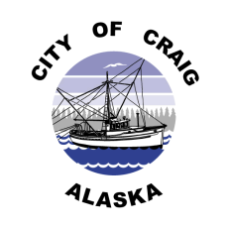

**Job Opening**

**Job Title:** **Temporary Part-Time Recreation Assistant**

**Pay Rate:** $14.00/hr. - $16.99/hr. DOE (Grade 2)

Part-Time Temporary Position

**Department:** Recreation, City of Craig

**Date Posted:** March 28, 2021

**Position Summary**

Under the general direction of the Recreation Director, the Recreation Assistant is responsible for assisting in the planning, developing, coordinating, implementing, and supervising recreation and athletic programs for the City of Craig Recreation program. Must be available afternoons, weekends and possibly evenings.

**Qualifications**

* Must be 18+ years of age.
* Must be good at managing and working to a schedule.
* Must have good knowledge of youth sports and community recreation, and be able to work well with the public, particularly children.
* Background check required.

**Specific Duties**

* Open and close the City Gym and Youth Center.
* Supervise the after-school program, mini camps, and the youth nights held at the Craig Youth & Recreation Center and the City Gym. Assist with the Swap Meets, Bazaars, Harvest Festival and Salmon Social and sports leagues.
* Help volunteers to use recreation facilities.
* Assist in planning, organizing, developing, scheduling, and supervising all events and activities sponsored by the Recreation Department.
* Assist in advertising for programs and events through several different mediums including the internet, radio, and posting signs around the community.

**Applications**

Complete job description and application are available at Craig City Hall, 500 Third Street, or online at [www.craigak.com](http://www.craigak.com). Please submit completed applications to [hr@craigak.com](mailto:hr@craigak.com), or drop off at City Hall. ***Position open until filled***.

***The City of Craig is an Equal Opportunity Employer***