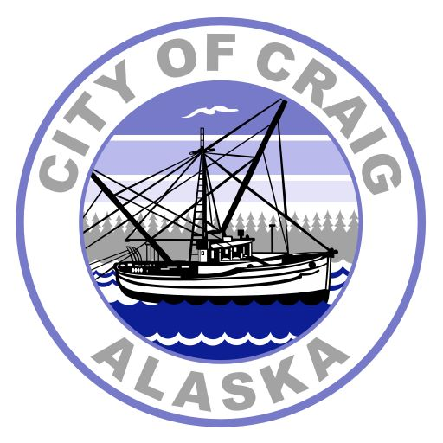
Craig City Gym & Youth Center Rental Form
(City Office keeps this form)

Fees

Craig Gym Rental $20/hour Non-profit $15/hour
Youth Center Rental $25/hour Skates $50/hour
Ball Access $10/hour Speaker Rental $50/day
PA System $50/day
Note: For skate rental contact City of Craig at (907) 826-3275
Note: Additional equipment subject to approval and fees

Date Requested: ___________________

Rental Date: ______________________
Start Time: ___________ End Time: _______________ Total time: ______________
Circle Proposed Building of Rental: Craig City Gym or Youth Center
Activity/Proposed Use/Equipment use proposed: ___________________________________
Adult Responsible (must be present during rental period): ___________________

Renter: ________________________ Work Phone: _______________ Cell Phone: _______________
Address: _____________________________ E-mail: _________________________________

Rental Agreement
I have read and agree to abide by the rules provided to me in connection with my request to rent the Craig City Gym. By my signature, I acknowledge receipt of these rules and of the clean-up checklist provided with this form.
Signed: ______________________________ Date: ________________________

Hold Harmless Agreement
I recognize that the activity I propose to conduct at the City Gym involves the risk of injury and by entering into this agreement, I, _____________________, as the person in charge, agree to defend, indemnify, and hold harmless the City of Craig, its representatives, and/or assignees for injury or property damage suffered by myself or anyone in connection with or incident to the rental of the Craig City Gym under this agreement.

Signed: ______________________________ Date: ________________________

Administrative Use Only

City Employee: ___________________________ Marked on Calendar

Total hours of rental: __________ Rental Rate: __________
Equipment Fees: ___________ + Building Rental: __________ = Total Rental Fee: _______________
Date rental was paid: ________________
Key signed out Returned City Employee Initial to confirm return of key: _________

Craig City Gym Rental Form
(Renter takes this form with them)

Renter: ______________________ Rental Date: ______________________
All required funds received: ___________________________ (required prior to receipt of gym key)

RENTAL AGREEMENT
- Rental time starts when you enter the gym and ends when you leave.
- Arrange to pick up the key prior to your rental. The key may be picked up M-F 8am-5pm at City Hall. Or you may pick up the key at the Police Station after hours or on holidays. A receipt showing payment of deposit and rental fee will be required to pick up the key.
- Do not drag tables, chairs, or other heavy objects; take care not to scratch the floor.
- NO nails, staples or tacks may be used on walls, floors or bleachers.
- To receive a deposit refund, the gym must be left in a clean and orderly fashion. All chairs, tables, and other equipment must be returned to it storage area. Floors must be swept and mopped; bathrooms must be cleaned; garbage must be emptied to dumpster; parking lot must be picked up. Lights must be turned off, and heat turned down.
- Return this form with the key to the Police Station or the City Hall drop box in the front entrance immediately following your rental.
- You may pick up your deposit check at City Hall after 1pm of the first business day following your rental. Rental deposit return is dependent upon satisfactory condition of the gym and timely return of the gym key.

- Violation of these rules will result in termination of the rental agreement.
- Refunds of deposit and rental fee will be given upon written notification of rental cancellation at least two business days prior to rental date.
- Damage discovered during the inspection by staff after the rental period will result in an assessment against the renting party. If you notice damage upon entering the gym prior to your rental, please report it to the Craig Police Department at 826-3330 or to the Recreation Director, 826-2575.
- All lost and found items will be taken to POWER.

Craig City Gym Clean-up Form
(Renter takes this form with them)

Renter: ______________________ Rental Date: ______________________

Please return this completed form with your gym key. We will use this form to verify that all items have been addressed and that the gym was in satisfactory condition after your rental. If for any reason these items are not completed timely or satisfactorily, the City of Craig will retain all or a portion of your deposit to cover the cost of any time required to return the gym to rentable condition.

Gym Care Checklist Done Verified by

Equipment put away ______________ _______________
Tables/chairs cleaned ______________ _______________
Behind bleachers clean ______________ _______________

Bathrooms cleaned ______________ _______________
Floors swept/mopped ______________ _______________
Lights Out

Stage ______________ _______________
Halls ______________ _______________
Bathrooms ______________ _______________
Parking lot cleaned ______________ _______________
Garbage taken to dumpster ______________ _______________

All doors locked ______________ _______________

Key returned with completed form ______________ _______________

To help you clean:

- Garbage bags, mop, cleaner, & paper towels are located inside double doors (use the gym key for access).
- Broom, dust mop, and dustpan are located by the front door.
- Tables belong under the stage (wipe down with cleaner and paper towels first).
- Chairs and extra tables belong in the locker room.

Credit Card Deposit Form Date________________
(City Office keeps this form)

Name on Card_____________________________ Phone #____________________

Billing Address_________________________________________________________

CC# _____________________________________ Exp __/__

Deposit Amount $___________

Name of Renter_____________________________ Date of Rental______________

I hereby authorize City of Craig to process the above credit card for full payment against any Damages or Cleaning Fees incurred in association with renting the Craig City Gym and/or any City of Craig equipment.

X__________________________________________

City of Craig Parks and Recreation Department
PO Box 725, Craig AK 99921
(907) 826-3275

Equipment Use Form

Equipment being used _____________________________________Qty____
_____________________________________Qty____
_____________________________________Qty____

Equipment will be used @ ___________________________________ (physical address)
_____________________________________

Date equipment will be:
picked up __________________________
returned __________________________

Responsible party Name ____________________________
Address____________________________
____________________________
Phone #____________________________

I will return equipment in the same or better condition than I borrowed it, on the date stated, or I understand I will lose my deposit and may be billed for damages and/or replacing equipment.

Signature_______________________________________ Date_______________________

Office use:
Deposit amount ________
Equipment returned on __________
Equipment damaged ____yes ____no

